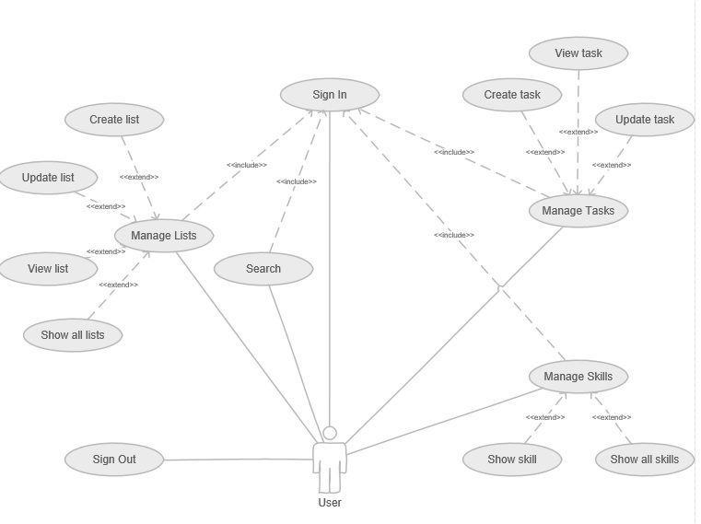

**Flow of events for use-case “Sign In”**

*Short description*

Use-case “Sign In” occurs, when user wants to log into app.

*Main flow of events*

1. Open app
2. Enter email and password
3. Click “Sign In” button
4. If credentials are invalid turn to alternative flow
5. App creates session for user

*Alternative flow of events*

1. App prompts user to re-enter credentials

*Post conditions*

User logged in app.

**Flow of events for use-case “Sign Out”**

*Short description*

Use-case “Sign Out” occurs, when user wants to log out.

*Main flow of events*

1. Click “Sign Out” button
2. Confirm sign out.
3. App cancels user session

*Post conditions*

User logged out.

**Flow of events for use-case “Create task”**

*Short description*

Use-case “Create task” occurs, when user wants to create a new task.

*Main flow of events*

1. Click “Create Task” button
2. Fill in data
3. Click “Save Task” button
4. App saves new task to database

*Post conditions*

New task added.

**Flow of events for use-case “Edit task”**

*Short description*

Use-case “Edit task” occurs, when user wants to edit a task.

*Main flow of events*

1. Click “Edit Task” button
2. Change task data
3. Click “Save Task” button
4. App saves changes to database

*Post conditions*

Task info saved.

**Flow of events for use-case “View task”**

*Short description*

Use-case “View task” occurs, when user wants to view a task info.

*Main flow of events*

1. Click on task list item
2. App gets task info from database
3. App shows task info.

*Post conditions*

Task info displayed.

**Flow of events for use-case “Show skill”**

*Short description*

Use-case “Show skill” occurs, when user wants to view a skill info.

*Main flow of events*

1. Click on skill list item
2. App gets skill info from database
3. App shows skill info

*Post conditions*

Skill info displayed.

**Flow of events for use-case “Show skills”**

*Short description*

Use-case “Show skills” occurs, when user wants to view all skills info.

*Main flow of events*

1. Click “Skills” button
2. App gets all skills info from database
3. App shows info for all skills

*Post conditions*

Skills list displayed.

**Flow of events for use-case “Search”**

*Short description*

Use-case “Search” occurs, when user wants to search for a task, list or skill.

*Main flow of events*

1. Enter search criteria in “Search” field
2. Click “Search” button
3. App scans database by entered criteria
4. App shows results

*Post conditions*

Search results displayed.

**Flow of events for use-case “Create list”**

*Short description*

Use-case “Create list” occurs, when user wants to create a new list.

*Main flow of events*

1. Click “Create List” button
2. Fill in data
3. Click “Save List” button
4. App saves new list to database

*Post conditions*

New list added.

**Flow of events for use-case “Edit list”**

*Short description*

Use-case “Edit list” occurs, when user wants to edit a list.

*Main flow of events*

1. Click “Edit List” button
2. Change task data
3. Click “Save List” button
4. App saves changes to database

*Post conditions*

List info saved.

**Flow of events for use-case “View list”**

*Short description*

Use-case “View list” occurs, when user wants to view a list info.

*Main flow of events*

1. Click on list item
2. App gets task info from database
3. App shows list info.

*Post conditions*

List info displayed.

**Flow of events for use-case “View skills”**

*Short description*

Use-case “View skills” occurs, when user wants to view all lists at once.

*Main flow of events*

1. Click “Lists” button
2. App gets all lists info from database
3. App shows info for all lists

*Post conditions*

All lists displayed.